**CE101 Engineering Drawing July- Nov 2019**

**Indian Institute of Technology Guwahati**

**Lab Sheet-10 Isometric Projections Friday Morning**

**Max Marks: 80 Date: 01.11.2019**

**Q. 1 Draw the three possible ways of representing the isometric projection of a pentagonal prim side of base 40 mm and height 70 mm. [15 marks]**

**Q. 2 Following figure shows orthographic views of an object. Draw its ISOMETRIC VIEW. [15 marks]**

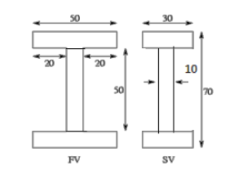

**Q.3 A cylinder of 40 mm diameter and 70 mm height stands on HP. A section plane perpendicular to VP and inclined at angle of 60° to HP cuts the solid at a point on the axis 20 mm from the top. Draw the isometric view of the truncated cylinder showing the cut surface. [25 marks]**

**Q.4 Following figure shows orthographic views of an object. Draw its ISOMETRIC VIEW. [25 marks]**

